**TUGAS 04**

**PRAK05 Package**



Praktikum Pemrograman Berbasis Web - A

Nama :

Adelia Nurlina Putri 4521210059

**PROGRAM STUDI S1 TEKNIK INFORMATIKA**

**FAKULTAS TEKNIK**

**UNIVERSITAS PANCASILA**

**JAKARTA**

**2024**

1. **Project tanya_daku**
   1. **First Initialization**
2. Akses web <https://docs.flutter.dev/ui/layout/tutorial>
3. Buka Android Studio

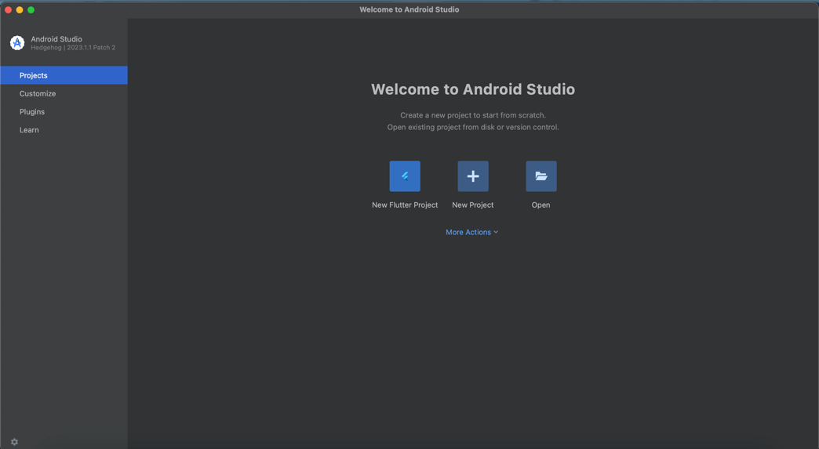

1. Pilih New Flutter Project -> Flutter -> Next

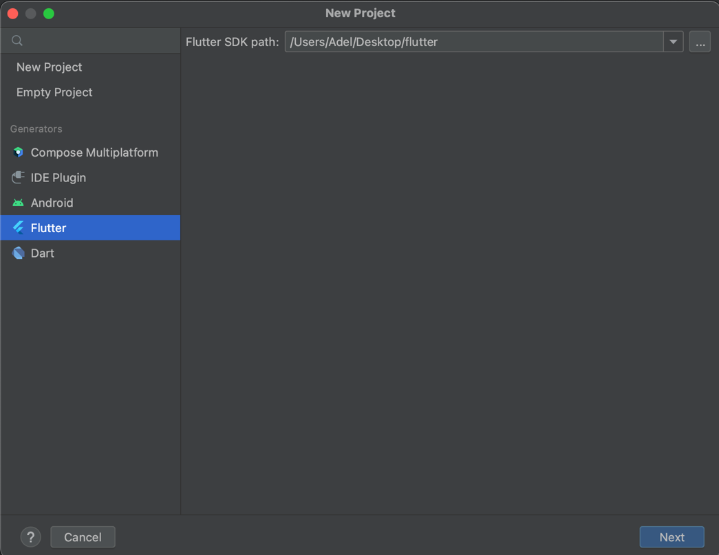

1. Isi form untuk nama project, tempat project, type, bahasa pemrograman, platforms dan lainnya -> Create

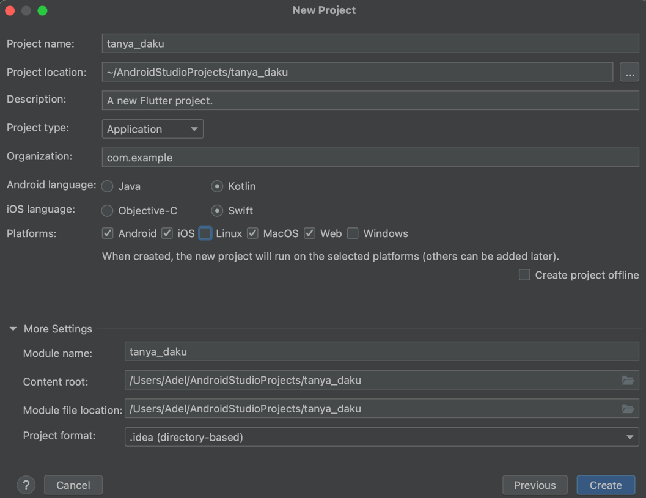

* 1. **Membuat Layout Dasar**

1. File main.dart

|  |
| --- |
| import 'package:flutter/material.dart';  void main() {  runApp(const TanyaDakuApp());  }  class TanyaDakuApp extends StatelessWidget {  const TanyaDakuApp({super.key});  @override  Widget build(BuildContext context) {  return const MaterialApp(  home: HalamanBola(),  );  }  }  class HalamanBola extends StatelessWidget {  const HalamanBola({super.key});  @override  Widget build(BuildContext context) {  return Scaffold(  appBar: AppBar(  backgroundColor: Colors.blue[900],  title: const Text(  "Tanya Daku Apa Saja",  style: TextStyle(  color: Colors.white,  fontWeight: FontWeight.bold,  ),  ),  ),  body: Container(  color: Colors.blue,  ),  );  }  } |

* + - * Pada main() function runApp(const TanyaDaku)
      * Class TanyaDaku adalah extends dari StatelessWidget
      * Return dari class TanyaDaku adalah MaterialApp yang di dalamnya terdapat property home:
      * Home: memanggil class HalamanBola()
      * Class HalamanBola() berisi:
        1. appBar backgroundColor warnanya dark blue dan ada title “Tanya Daku Apa Saja” dengan warna putih bold.
        2. Body Container dengan backgroundColor blue

1. Run

|  |
| --- |
| Pilih Simulator -> Klik Ikon Run |

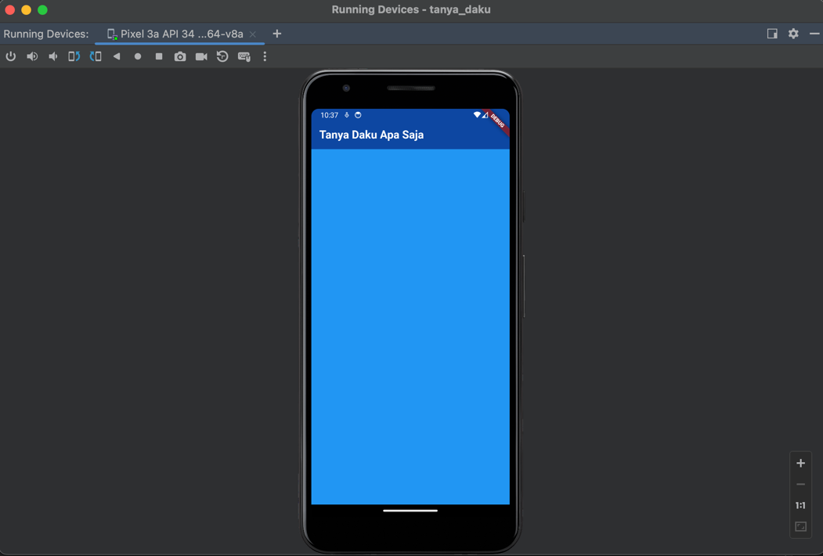

* 1. **Membuat Stateful Widget**
     1. Membuat Directory Images

|  |
| --- |
| Klik kanan project -> New -> Directory -> Copy images to directory |

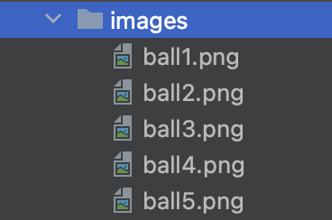

* + 1. Menambahkan asset pada pubspec.yaml

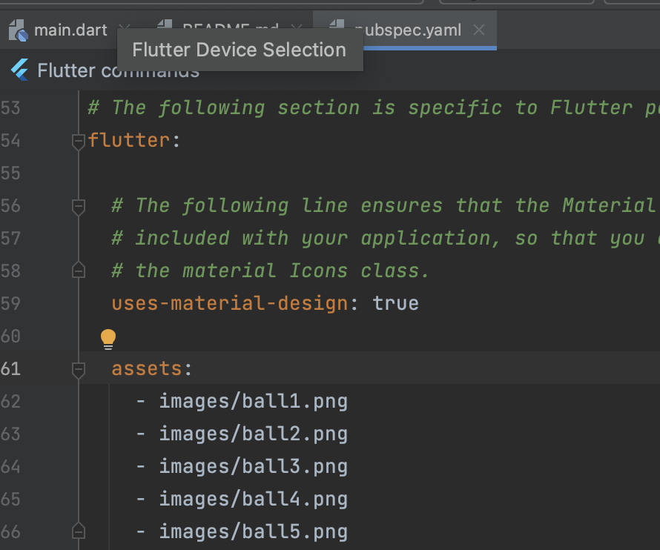

* + 1. Update asset

|  |
| --- |
| $ flutter pub get |

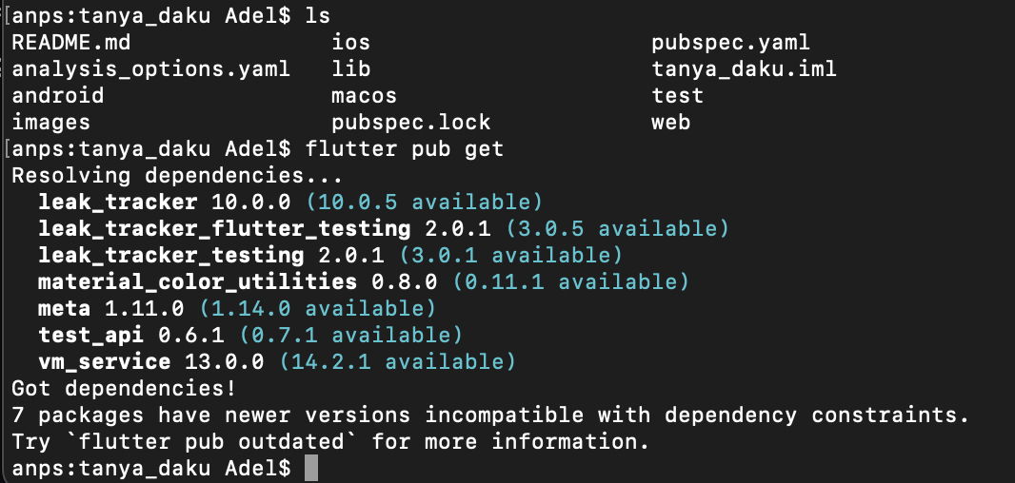

* + 1. Edit main.dart

|  |
| --- |
| import 'package:flutter/material.dart';  import 'dart:math';  void main() {  runApp(const TanyaDakuApp());  }  class TanyaDakuApp extends StatelessWidget {  const TanyaDakuApp({super.key});  @override  Widget build(BuildContext context) {  return const MaterialApp(  home: HalamanBola(),  );  }  }  class HalamanBola extends StatelessWidget {  const HalamanBola({super.key});  @override  Widget build(BuildContext context) {  return Scaffold(  appBar: AppBar(  backgroundColor: Colors.blue[900],  title: const Text(  "Tanya Daku Apa Saja",  style: TextStyle(  color: Colors.white,  fontWeight: FontWeight.bold,  ),  ),  ),  body: const Bola(),  backgroundColor: Colors.blue,  );  }  }  class Bola extends StatefulWidget {  const Bola({super.key});  @override  State<Bola> createState() => _BolaState();  }  class _BolaState extends State<Bola> {  int nomorBola = 1;  @override  Widget build(BuildContext context) {  return Center(  child: Image.asset(  'images/ball1.png'  ),  );  }  } |

* Buat sebuah class StatefulWidget baru bernama Bola.
* Pada class HalamanBola di dalamnya terdapat property body dengan class/widget Container, ganti dengan class Bola tadi.
* Pada class Bola, tampilkan ball1.png dan berada di tengah.
  + 1. Run app

|  |
| --- |
| Pilih simulator -> Klik Icon Run |

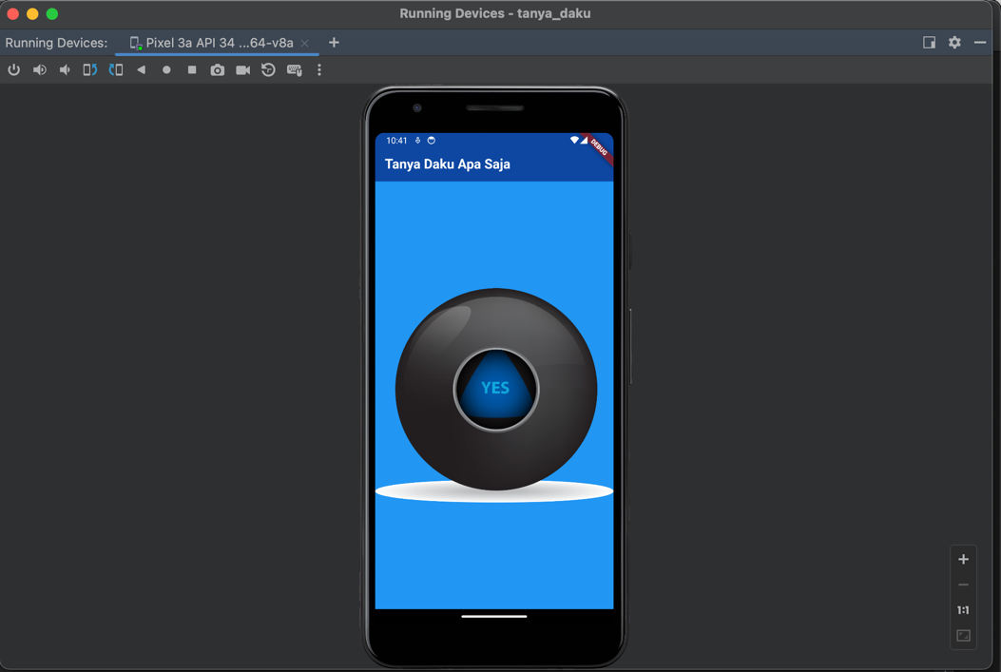

* 1. **Membuat Jadi Interaktif**
     1. Edit main.dart

|  |
| --- |
| import 'package:flutter/material.dart';  import 'dart:math';  void main() {  runApp(const TanyaDakuApp());  }  class TanyaDakuApp extends StatelessWidget {  const TanyaDakuApp({super.key});  @override  Widget build(BuildContext context) {  return const MaterialApp(  home: HalamanBola(),  );  }  }  class HalamanBola extends StatelessWidget {  const HalamanBola({super.key});  @override  Widget build(BuildContext context) {  return Scaffold(  appBar: AppBar(  backgroundColor: Colors.blue[900],  title: const Text(  "Tanya Daku Apa Saja",  style: TextStyle(  color: Colors.white,  fontWeight: FontWeight.bold,  ),  ),  ),  body: const Bola(),  backgroundColor: Colors.blue,  );  }  }  class Bola extends StatefulWidget {  const Bola({super.key});  @override  State<Bola> createState() => _BolaState();  }  class _BolaState extends State<Bola> {  int nomorBola = 1;  @override  Widget build(BuildContext context) {  return Center(  child: TextButton(  onPressed: () {  print("Saya baru saja ditekan");  },  child: Image.asset(  'images/ball1.png'  ),  ),  );  }  } |

* Gunakan TextButton widget agar gambar menjadi clickable
* Tambahkan sebuat pernyataan print yang terpicu akibat gambar tersebut ditekan. Tampilkan “Saya baru saja ditekan”
* Ketika aplikasi dijalankan dan gambar bola ditekan maka akan muncul “Saya baru saja ditekan” pada console.
  + 1. Run app

|  |
| --- |
| Pilih simulator -> Klik Icon Run |

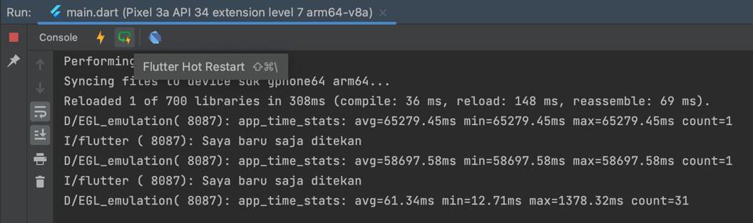

* 1. **Jadikan Acak**
     1. Edit main.dart

|  |
| --- |
| import 'package:flutter/material.dart';  import 'dart:math';  void main() {  runApp(const TanyaDakuApp());  }  class TanyaDakuApp extends StatelessWidget {  const TanyaDakuApp({super.key});  @override  Widget build(BuildContext context) {  return const MaterialApp(  home: HalamanBola(),  );  }  }  class HalamanBola extends StatelessWidget {  const HalamanBola({super.key});  @override  Widget build(BuildContext context) {  return Scaffold(  appBar: AppBar(  backgroundColor: Colors.blue[900],  title: const Text(  "Tanya Daku Apa Saja",  style: TextStyle(  color: Colors.white,  fontWeight: FontWeight.bold,  ),  ),  ),  body: const Bola(),  backgroundColor: Colors.blue,  );  }  }  class Bola extends StatefulWidget {  const Bola({super.key});  @override  State<Bola> createState() => _BolaState();  }  class _BolaState extends State<Bola> {  int nomorBola = 0;  @override  Widget build(BuildContext context) {  return Center(  child: TextButton(  onPressed: () {  setState(() {  nomorBola = Random().nextInt(4);  print("$nomorBola");  });  },  child: Image.asset(  'images/ball1.png'  ),  ),  );  }  } |

* Buatkan variable nomorBola dengan tipe data integer dan set nilainya 0.
* Tambahkan library dart:math
* Sekarang acak angkanya antara 0-4 gunakan Random().nextInt(nilaiMax)
* Tampilkan nilainya di console.
  + 1. Run app

|  |
| --- |
| Pilih simulator -> Klik Icon Run |

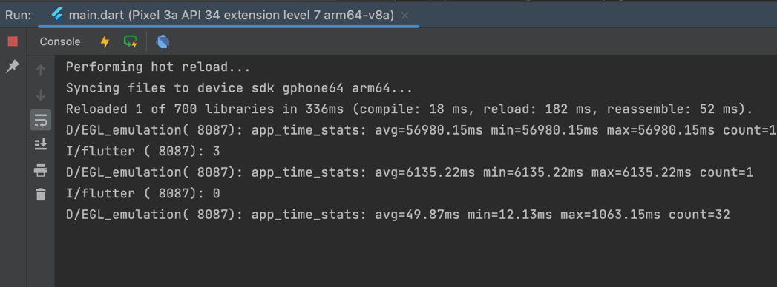

* 1. **Mutahirkan/Update State**
     1. Edit main.dart

|  |
| --- |
| import 'package:flutter/material.dart';  import 'dart:math';  void main() {  runApp(const TanyaDakuApp());  }  class TanyaDakuApp extends StatelessWidget {  const TanyaDakuApp({super.key});  @override  Widget build(BuildContext context) {  return const MaterialApp(  home: HalamanBola(),  );  }  }  class HalamanBola extends StatelessWidget {  const HalamanBola({super.key});  @override  Widget build(BuildContext context) {  return Scaffold(  appBar: AppBar(  backgroundColor: Colors.blue[900],  title: const Text(  "Tanya Daku Apa Saja",  style: TextStyle(  color: Colors.white,  fontWeight: FontWeight.bold,  ),  ),  ),  body: const Bola(),  backgroundColor: Colors.blue,  );  }  }  class Bola extends StatefulWidget {  const Bola({super.key});  @override  State<Bola> createState() => _BolaState();  }  class _BolaState extends State<Bola> {  int nomorBola = 1;  @override  Widget build(BuildContext context) {  return Center(  child: TextButton(  onPressed: () {  setState(() {  nomorBola = Random().nextInt(5) + 1;  });  },  child: Image.asset(  'images/ball$nomorBola.png'  ),  ),  );  }  } |

* Ganti angka acaknya dari 0-4 menjadi 1-5 agar cocok dengan nomor bola di galeri images.
* Daripada hard coded untuk emnampilkan gambar bola, gunakan variable nomorBola untuk menampilkan gambar secara acak.
* Gunakan setState() untuk memutakhirkan/update gambar awal ketika nomorBola nilainya berubah.
  + 1. Run app

|  |
| --- |
| Pilih simulator -> Klik Icon Run |

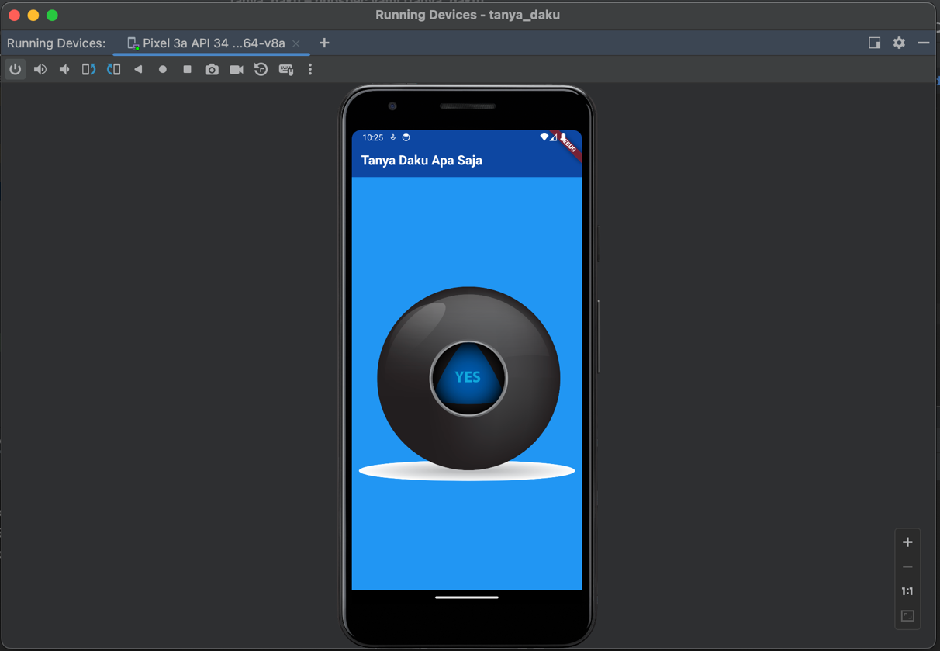

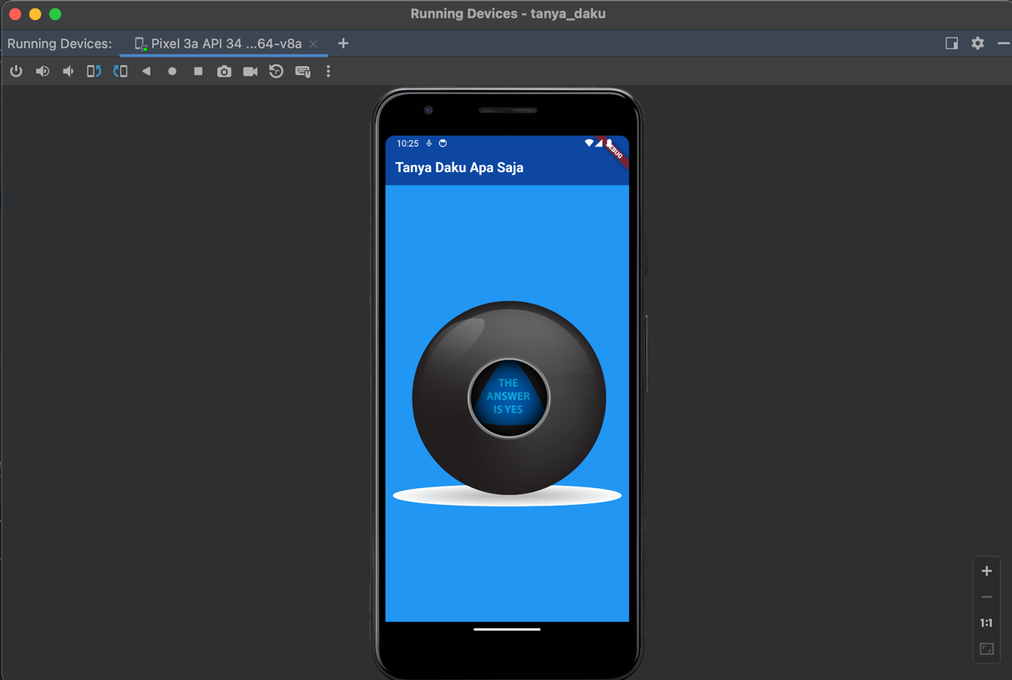

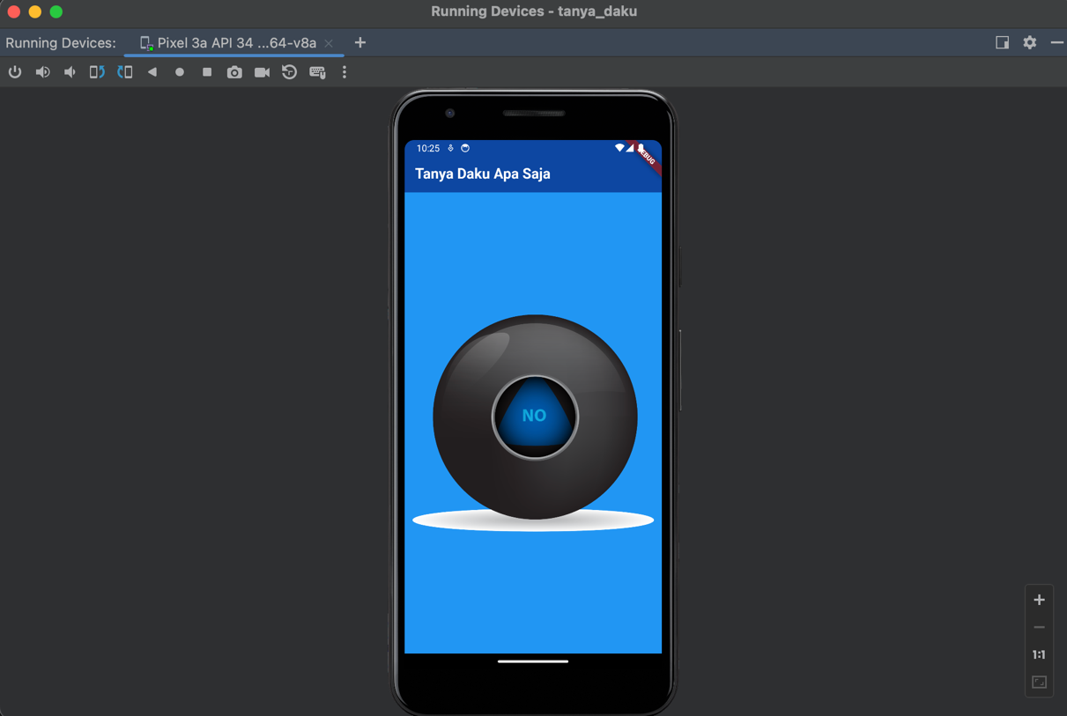

1. **Project tanya_daku**
   1. **First Initialization**
2. Akses web <https://docs.flutter.dev/ui/layout/tutorial>
3. Buka Android Studio



1. Pilih New Flutter Project -> Flutter -> Next



1. Isi form untuk nama project, tempat project, type, bahasa pemrograman, platforms dan lainnya -> Create

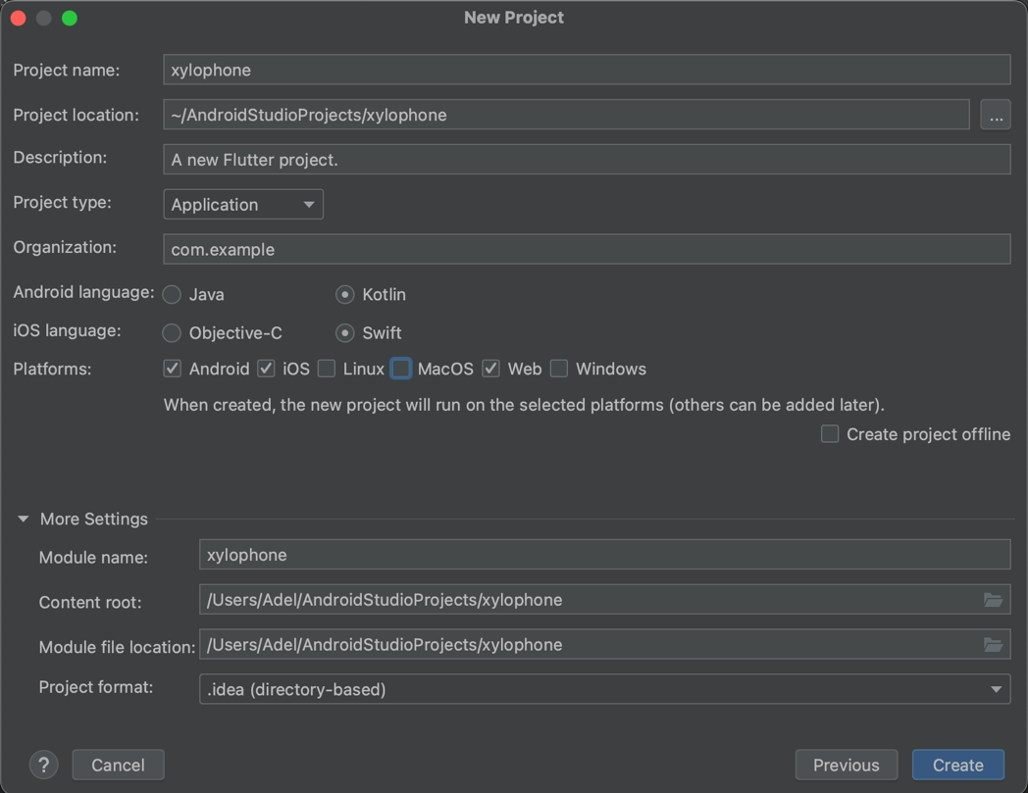

1. Update pub flutter

|  |
| --- |
| $ flutter pub get |

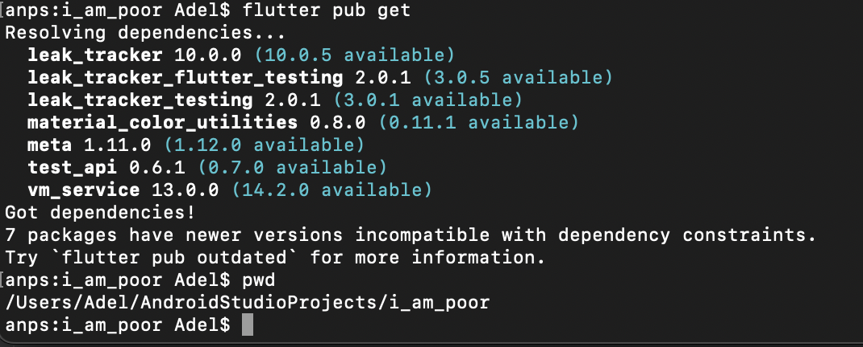

* 1. **Membuat Stateful Widget**
     1. Membuat Directory Images

|  |
| --- |
| Klik kanan project -> New -> Directory -> Copy images to directory |

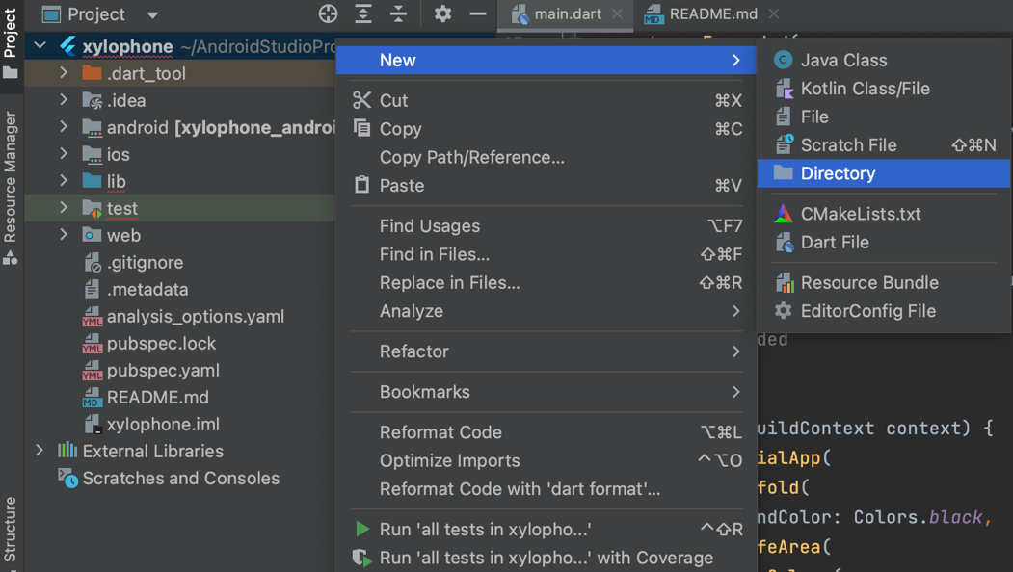

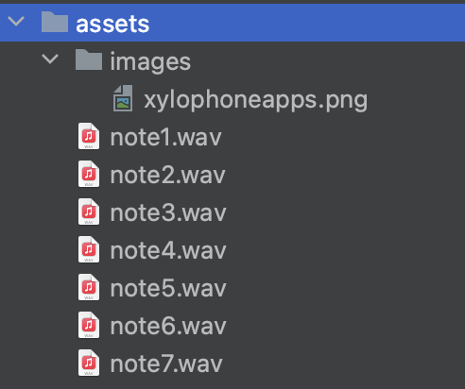

* + 1. Menambahkan asset pada pubspec.yaml

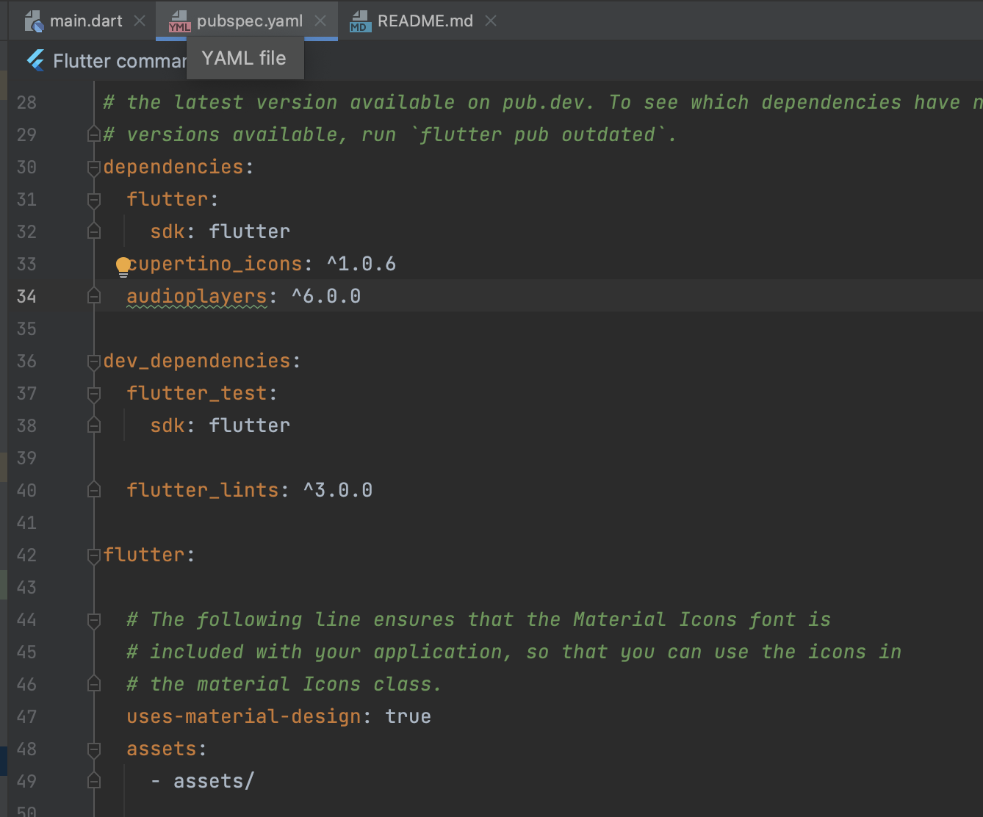

* + 1. Update asset

|  |
| --- |
| $ flutter pub get |

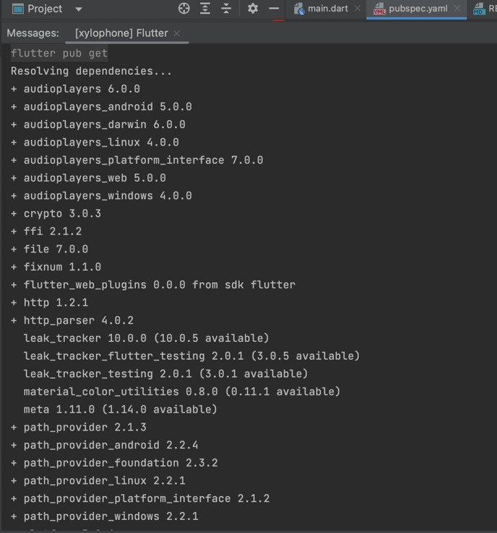

* + 1. Edit main.dart

|  |
| --- |
| import 'package:flutter/material.dart';  import 'package:audioplayers/audioplayers.dart';  void main() => runApp(const XylophoneApp());  class XylophoneApp extends StatelessWidget {  const XylophoneApp({super.key});  void playSound(int soundNumber) {  final player = AudioPlayer();  player.play(AssetSource('note$soundNumber.wav'));  }  Expanded buildKey({required int soundNumber, required Color buttonColor}) {  return Expanded(  child: TextButton(  style: TextButton.styleFrom(  backgroundColor: buttonColor,  ),  onPressed: () {  playSound(soundNumber);  },  child: Text('soundNumber: $soundNumber'),  )  );  }  @override  Widget build(BuildContext context) {  return MaterialApp(  home: Scaffold(  backgroundColor: Colors.black,  body: SafeArea(  child: Column(  crossAxisAlignment: CrossAxisAlignment.stretch,  children: <Widget>[  buildKey(soundNumber: 1, buttonColor: Colors.red),  buildKey(soundNumber: 2, buttonColor: Colors.orange),  buildKey(soundNumber: 3, buttonColor: Colors.yellow),  buildKey(soundNumber: 4, buttonColor: Colors.green),  buildKey(soundNumber: 5, buttonColor: Colors.teal),  buildKey(soundNumber: 6, buttonColor: Colors.blue),  buildKey(soundNumber: 7, buttonColor: Colors.purple),  ],  ),  ),  ),  );  }  } |

* + 1. Run app

|  |
| --- |
| Pilih simulator -> Klik Icon Run |

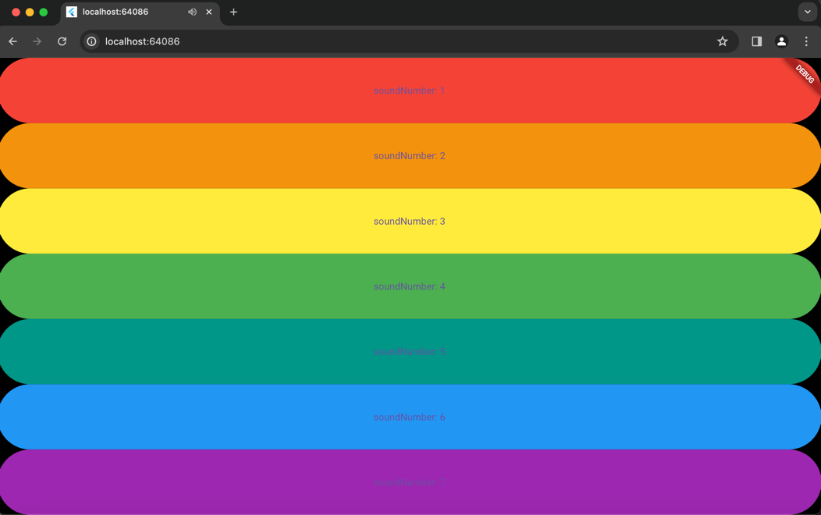

1. **Push Code to GitHub** <https://github.com/adelianurlinap/Prak_PBM.git>
2. Clone Repository yang telah dibuat :

|  |
| --- |
| git clone https://github.com/adelianurlinap/Prak_PBM.git |

1. Add dan commit

|  |
| --- |
| git add .  git commit -m "Tugas4" |

1. Push code

|  |
| --- |
| git push |

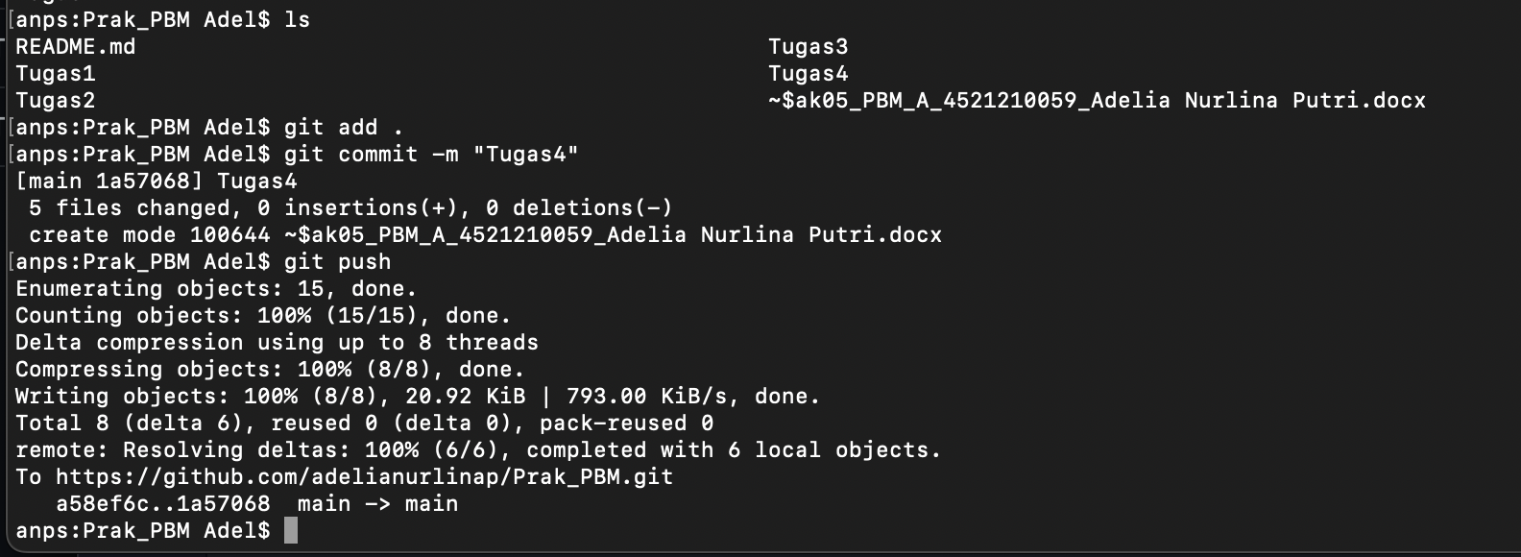

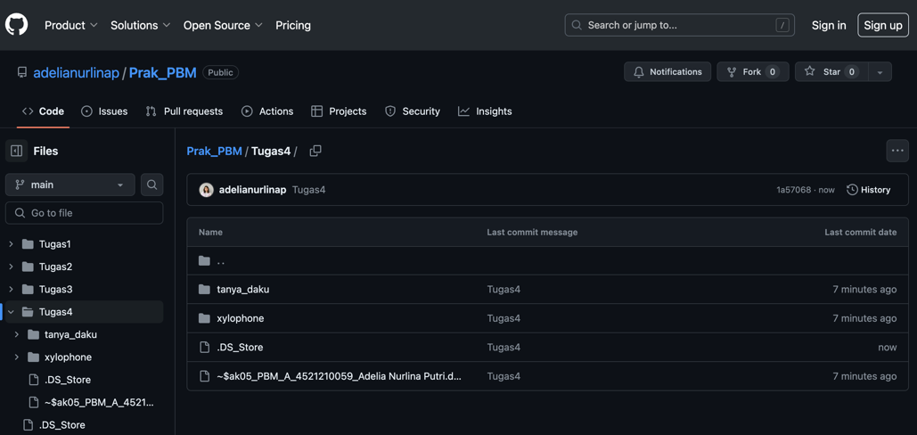

1. **Kesimpulan**

Pada tugas 4 ini, telah dilakukan praktek untuk membuat stateful app dan app dengan package.

1. Referensi

<https://github.com/adiwp/MobileProjects>